Resume of Dr. Pooja Tyagi
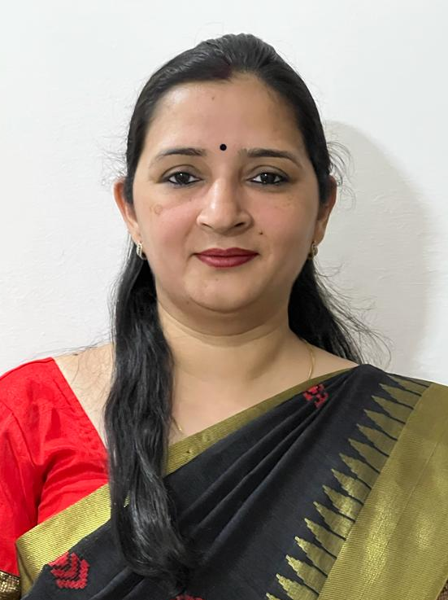

Present Address: B-4, Chaudhary Towers, Jadugar Road

Civil Lines, Roorkeee – 247 667

(Haridwar), Uttarakhand

E-mail- poojaiitrv@gmail.com

Mob. +91 6396587100

Academic Performance

Doctor of Philosophy in Chemistry (Ph.D.) (07/2008)
Department of Chemistry, Indian Institute of Technology Roorkee
Thesis: Synthesis, Characterization and Catalytic Activity of Manganese and Zinc Complexes
Advisor: Prof. U.P. Singh, Indian Institute of Technology Roorkee (IITR), India

Master of Science in Chemistry (M.Sc.) (07/2004) (Grade Point- 8.19 on 10-point scale)
Department of Chemistry, Indian Institute of Technology Roorkee
Thesis: Reactions of 2-Cynapyrazine with Some Mono and Diamines
Advisor: Prof. S.M. Sondhi, Indian Institute of Technology Roorkee (IITR), India

Bachelor of Science (B.Sc.) (07/2002) (1st Division, 74.55%)
K.L.D.A.V. (P.G.) College, Roorkee (Affiliated to Ch. Charan Singh Univ., Meerut, India)

Professional Experience
- Assistant Professor, Methodist Girls PG College, Roorkee, India. (August 2020-Continue)
- Lecturer, Department of Chemistry, K. L. D. A. V. (PG) College Roorkee, India. (Aug 2018-May 2020)
- Post-Doctoral Researcher, Department of Chemistry, National Dong Hwa University (NDHU), Hualien, Taiwan. (Sept 2010-Feb 2012)
- Lecturer, Department of Chemistry, K. L. D. A. V. (PG) College, Roorkee, India (Aug 31-Dec 5, 2009)
- Senior Research Fellow, Department of Chemistry, Indian Institute of Technology Roorkee, Roorkee, India. (Aug 2008- Aug 2010)

List of Publications
Journals
- Udai P. Singh, Asish K. Sharma, Pooja Tyagi, Shailesh Upreti, Raj K. Singh, “Mononuclear manganese carboxylate complexes: Synthesis and structural studies”, Polyhedron, 25 (2006), 3628–3638.
- Udai P. Singh, Pooja Tyagi, Shailesh Upreti, “Manganese complexes as models for manganese-containing pseudocatalase enzymes: Synthesis, structural and catalytic activity studies”, Polyhedron, 26 (2007), 3625–3632.
- Udai P. Singh, Preeti Babbar, Asish K. Sharma, Pooja Tyagi and Thomas Weyhermüller, “Mononuclear cobalt(II) hydroxo complex: Synthesis, molecular structure and catalytic studies”, Transition Metal Chemistry, 33 (2008), 931-940.
- Pooja Tyagi and Udai P. Singh, “Chloro and azido bonded manganese complexes: Synthesis, structural and magnetic studies”, Journal of Coordination Chemistry, 62 (2009), 1613-1622.
- Udai P. Singh, Pooja Tyagi and Souptik Pal, “Synthesis, structural and luminescence studies of some zinc complexes having pyrazole and carboxylate ligands”, Inorganica Chimica Acta, 362 (2009), 4403-4408.
- Pooja Tyagi and Udai P. Singh, “Manganese pyrazolyl borate complexes as model for Mn-containing metalloproteins”, Current Bioactive Compounds, 5 (2009), 296-320.
- N.K. Singh, M.K. Bharty, S.K. Kushawaha, U.P. Singh, Pooja Tyagi “Synthesis, spectral and structural studies of a Mn(II) complex of [N'-(pyridine-4-carbonyl)-hydrazine]-carbodithioic acid ethyl ester and Mn(II) and Ni(II) complexes of [N'-(pyridine-4-carbonyl)-hydrazine]-carbodithioic acid methyl ester”, Polyhedron, 29 (2010), 1902-1909.
- Subrata Chakraborty, Pooja Tyagi, Dar-Fu Tai, Gene-Hsiang Lee, and Shie-Ming Peng, “A Lead (II) 3D Coordination Polymer Based on a Marine Cyclic Peptide Motif”, Molecules, 18 (2013), 4972-4985.

Conference proceedings
- Tyagi, Pooja; Singh, U.P. “Zn(II) Complexes Containing Different Pyrazole Ligands: Effect of Steric Hinderence on Structure” Proceedings of Modern Trend in Inorganic Chemistry-XII, Indian Institute of Technology, Madras, India, 6th-8th, Dec., 2007, P-68.
- Participated in “9th CRSI, National Symposium in Chemistry”, University of Delhi, India, 1st-4th Feb., 2007.
- Tyagi, Pooja; Singh, U.P. “Synthesis of Zinc Hydroxo Complexes as catalyst for ester Hydrolysis” Proceedings of Modern Trend in Inorganic Chemistry-XI”, Indian Institute of Technology, Delhi, India, 8th-10th, Dec., 2005, P-62.

Short Term Courses/Workshop
  - Actively participated in 22nd Conference of Indian Council of Chemists and UGC sponsored symposium on “Thrust Areas in Chemistry” organized by the Department of Chemistry, Indian Institute of Technology Roorkee during October 17th-19th, 2003.
  - Actively participated in two days National Workshop on “Techniques and Challenges for Structure Solution in Chemical Crystallography” sponsored by Bruker-AXS, Germany held during August 31st-01st Sep., 2007 at Indian Institute of Technology Roorkee, India.

Academic Honors, Awards and Fellowships
- National Science Council (NSC), Post-Doctoral Research Fellowship (2010), to carry out the research at Department of Chemistry, National Dong Hwa University, Hualien, Taiwan. (September 2010-February 2012).
- Senior Research Fellowship (SRF) awarded by Council of Scientific and Industrial Research (CSIR), New Delhi,Government of India. (December 2007-August 2010).
- Junior Research Fellowship (JRF) awarded by Council of Scientific and Industrial Research (CSIR), New Delhi,Government of India. (December 2005-August 2007).
- All India rank 547 securing 83.28 % in All India Level GATE-2004 (Graduate Aptitude Test in Engineering) conducted by Indian Institute of Technology, Delhi, India.
- Qualified All India Level Junior Research Fellowship-National Eligibility Test (NET) (CSIR-JRF) in Chemical Sciences conducted by Council of Scientific and Industrial Research (CSIR), New Delhi, India.

Lab Skills
- Instrument Handled: NMR, GC, GC-MS, UV-Vis, IR, CHN Analyser, AAS, TGA, VSM, ESI-MS, SQUID magnetometer, HPLC, Cyclic Voltametery, Single Crystal X-ray Diffractometer
- Computer Awareness
  - Operating Systems: Windows Window95/98/ 2000/ Millennium/XP.
  - MS-Office 2000: Word, Excel, and PowerPoint
- Data Base: Scifinder, CCDC.
- Miscellaneous: Paint shop, Chem.Wind, Chem Draw, Origin, Corel Draw, Topspin, ISIS Draw, XShell, Shelx-TL, WinGX, Diamond, Mercury, Platon etc.

Personal Profile

Date of birth : 22th October, 1983
Gender : Female
Nationality : Indian
Permanent Address: B-4, Chaudhary Towers, Jadugar Road, Civil Lines, Roorkee-247667,
Uttarakhand
Marital Status : Married

Language Known

Hindi (Speaking & Writing)

English (Speaking & Writing)

Strong Points
- Hard working
- Dedication for achievement of goals
- Self confidence
- Team Leading skills
- Good communication skills

Referees

- Dr. U. P. Singh,
Professor (Supervisor)
Department of Chemistry
Indian Institute of Technology Roorkee
Roorkee- 247 667, India
E-mail: udaipfcy@iitr.ernet.in
Phone: +91-1332-285329(O)

- Dr. Ravi Bhushan,
Professor
Department of Chemistry
Indian Institute of Technology Roorkee
Roorkee- 247 667, India
E-mail: rbushfcy@iitr.ernet.in
Phone: +91-1332-285795(O)

- Dr. Kaushik Ghosh,
Associate Professor
Department of Chemistry
Indian Institute of Technology Roorkee
Roorkee- 247 667, India
E-mail: ghoshfcy@iitr.ernet.in
Phone: +91-01332-285547 (O)

